Veljko Marković

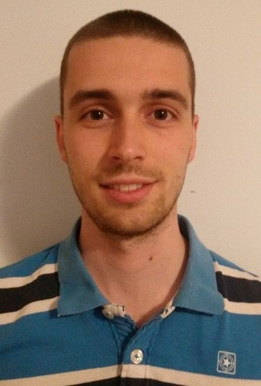  
  
Adress: Miljakovačke staze 51D

Mobile: 065-2589-004 • e-mail: [veljko8888@gmail.com](mailto:veljko8888@gmail.com)

Student e-mail: mv130137d@student.etf.rs

Birthday: 4th June, 1994.

**Personal Profile**

I am energetic, ambitious person, excellent in working with others to achieve a certain objective on time and with excellence. I am 4th year student (currently 7th semester) at Electrical Engineering Faculty in Belgrade (University of Belgrade, SOFTWARE ENGINEERING ). I passed all exams I had and I hope I will proceed my education in that successive way. Also, I am doing freelance projects in a 3 people team for the last 2 years. That projects are usually focused on web design and android development.

**Career Objective**

To secure a challenging position where I can effectively contribute my skills as Software Professional, possessing competent Technical skills.

**Education**

Primary school : VESELIN MASLEŠA, Belgrade, Voždovac

High school : 12th Belgrade Gimnasium, Belgrade, Voždovac

Faculty : Electrical Engineering, Software Engineering, 4th year, University of Belgrade

**Skills**

**Technical:** Pascal, C, C++, Java, Hibernate, C#, .NET, PHP, Laravel, Ajax, Javascript, JQuery, HTML, CSS, XML, JSON, SQL, 8086 asembler, Netbeans, Viusal Studio, Eclipse, JSP, JSF, REST, GIT.

**Interpersonal:** Verbal communication, Problem solving, Decision making, Assertiveness

**Driving:** B category driving licence

**Hobbies and interests**

I like sport, especially football.

**Faculty projects**

***Course: Operating Systems 1 – Multithreaded kernel for Intel8086***Realisation of the small, but very functional core of the operating system with support for time-sharing, context switching, event handling and synchronisation using semaphores. (C++)

***Course: Algorithms and data structures – Data structures with their common algorithms***

Implementation of stack, queue, tree, graphs, hash maps. (C)

***Course: Principles of software engineering***

Part of a 3 person team implementing “Elites” project (similar to Instagram application).

(PHP, MySQL, HTML, CSS, JavaScript, AJAX)

***Course: Electronic business infrastructure***

Realisation of a licitation web application on Azure platform which communicates with a database, with product bidding functionality. (C#, ASP/.NET, Javascript, Jquery, LINQ)

***Course: Web Application Programming***

Realisation of a small web application which communicates with a database. In this system there are 2 types of users: Traveler and Travel Agency. Depending on whether the user is logged in as Traveler or an Agency he/she can execute some functionality. (Java, Hibernate, MySQL, Netbeans)

**Career Experience**

I am doing freelance projects inside of a 3 people team for about 2 years. We are usually doing web development projects. Lately, we started focusing on learning Android development. Our projects are mainly done in Wordpress platform and also in PHP Laravel framework. Some of the latest web sites that we built are:  
<http://www.serbiamining.rs/>

<http://www.airsoft.co.rs/>

<http://mimishoneypot.com/>

Currently we are finishing the the web application which we worked for one German businessman. Application is soical network for 2 Europe cities – Munchen and Wien. Current version is at <http://ec2-35-156-50-5.eu-central-1.compute.amazonaws.com/> . Last version will be live and 100% functional on [www.citybooklet.com](http://www.citybooklet.com) in about one month.